型号 | HDMI 2.0 to 12G-SDI
产品图片 | 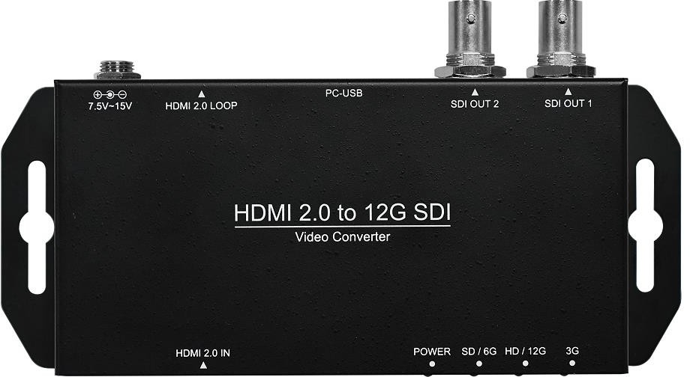
描述 | HDMI 2.0 to 12G-SDI Converter
特征 | - Multi-Standard Support ( 12G/6G/3G/HD/SD-SDI )  - Auto Source Format Detection
输入接口 | Video  - HDMI 2.0×1
输出接口 | Converted Video  - 12G-SDI×2  - HDMI 2.0×1
输入分辨率 | - HDMI 2.0  - 4096x2160p@60/50fps  - 4096x2160p@30/25/24fps  - 3840x2160p@60/50fps  - 3840x2160p@30/25/24fps  - 1920×1080p@60/50fps  - 1920×1080p@30/25/24fps  - 1920×1080i@60/50fps  - 1280×720p@60/50fps  - 720×480i@60fps  - 720×576i@50fps
输出分辨率 | HDMI : As input HDMI format SDI : As input HDMI format
音频输入 | HDMI : 8 Channels, 24bit, Up to 192KHz
音频输出 | SDI : 8 Channels, 24bit, 48KHz  HDMI : 8 Channels, 24bit, Up to 192KHz
Plug & Play | ✓
电源 | 7.5V ~ 15V

HDMI 2.0 to 12G-SDI规格书

2

尺寸 | L:143mm×W:63.6mm×H:34mm  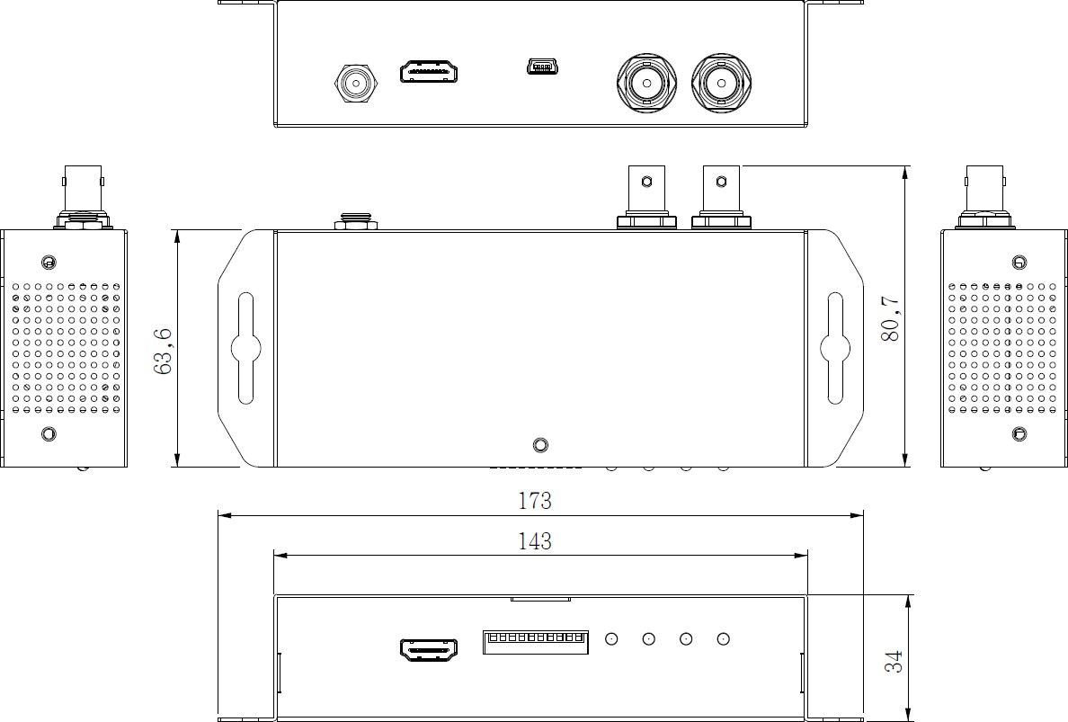

2/2

