Model | 12G-SDI to HDMI2.0-S
产品图片 | 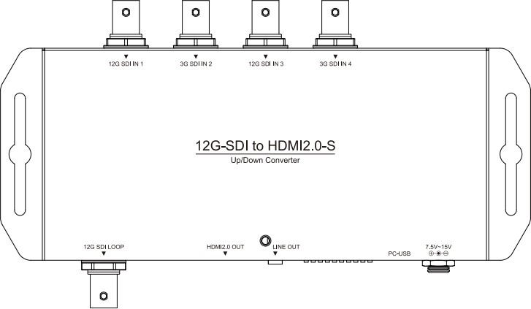
描述 | 12G-SDI/Quad-Link 3G-SDI to HDMI 2.0 Up/Down Converter
特征 | - Quad-Link 2 Sample Interleave ( 2SI ) Supported  - Square Division Quad Supported  - Quad-Link/Dual-Link/Single Link Supported  - 60fps ↔ 59.94fps Conversion  - Multi-Standard Support ( 12G/6G/3G/HD-SDI )  - Auto Source Format Detection
输入接口 | Video  - 12G-SDI×1  - 6G-SDI×1  - 3G-SDI×2  ( Dual-Link 6G-SDI, Quad-Link 3G-SDI Supported )
输出接口 | Up/Down Converted Video  - HDMI 2.0  Audio  - 3.5 mm Phone Jack×1  Loop-Through Video  - 12G-SDI×1
输入分辨率 | SDI  - 12G-SDI/Dual-Link 6G-SDI/Quad-Link 3G-SDI  - 4096x2160p@60/50fps  - 3840x2160p@60/50fps  - 6G-SDI  - 4096x2160p@30/25/24fps  - 3840x2160p@30/25/24fps  - 3G-SDI  - 1920×1080p@60/50fps  - HD-SDI  - 1920×1080p@30/25/24fps  - 1920×1080i@60/50fps

12G-SDI to HDMI2.0-S规格书

 | - 1280×720p@60/50fps
输出分辨率 | - HDMI 2.0 ( Up/Down Converted )  - 4096x2160p@60/50fps  - 4096x2160p@30/25/2 4fps  - 3840x2160p@60/50fps  - 3840x2160p@30/25/2 4fps  - 1920×1080p@60/50fp s  - 1920×1080p@30/25/2  4fps  - 1920×1080i@60/50fps  - 1280×720p@60/50fps  - 720×480i@60fps  - 720×576i@50fps | SDI ( Loop-Through )  - 12G-SDI  - 4096x2160p@60/50fps  - 3840x2160p@60/50fps  - 6G-SDI  - 4096x2160p@30/25/24fps  - 3840x2160p@30/25/24fps  - 3G-SDI  - 1920×1080p@60/50fps  - HD-SDI  - 1920×1080p@30/25/24fps  - 1920×1080i@60/50fps  - 1280×720p@60/50fps
音频输入 | SDI : Up to 8 Channels, 24bit, 48KHz
音频输出 | HDMI : Up to 8 Channels, 24bit, 48KHz  3.5 mm Phone Jack : 2 Channels, 24bit, 48KHz
Plug & Play | ✓
电源 | 7.5V ~ 15V
尺寸 | L:190mm×W:76mm×H:26mm  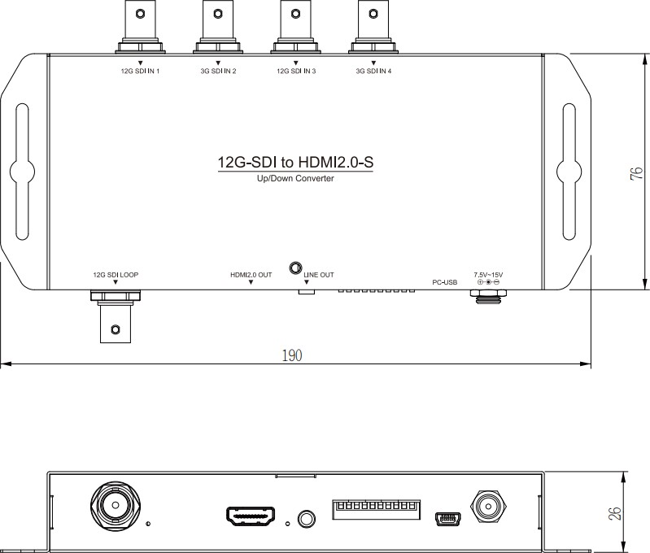

2/3

Connection Diagram | Single Link / Dual Link / Quad Link Connection  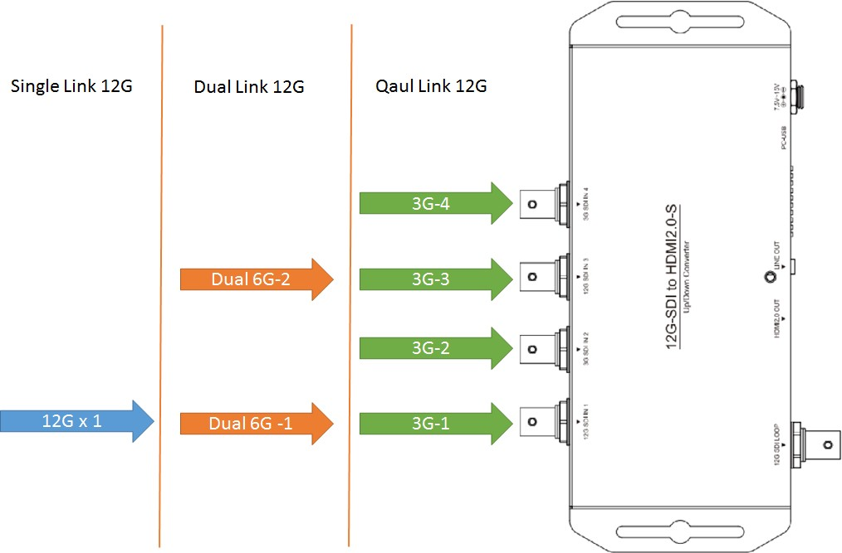  For 12G-SDI or 6G-SDI, User can connect it on 12G SDI IN 1 or 12G SDI IN 3  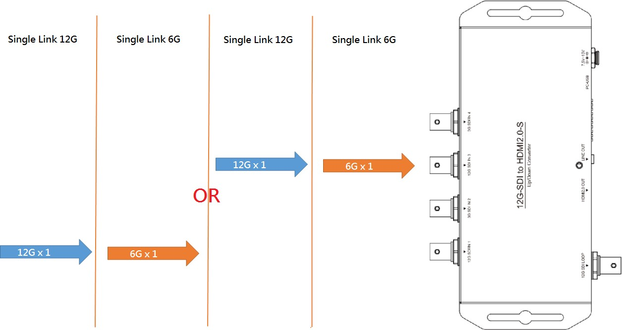

3/3

