4K 3D转换器规格书
2 × 12G-SDI/HDMI2.0 to 12G-SDI/HDMI2.0
UpDown Converter Series Hardware Specification
型号 | 2 × 12G-SDI/HDMI2.0 to 12G-SDI/HDMI2.0
图片 | 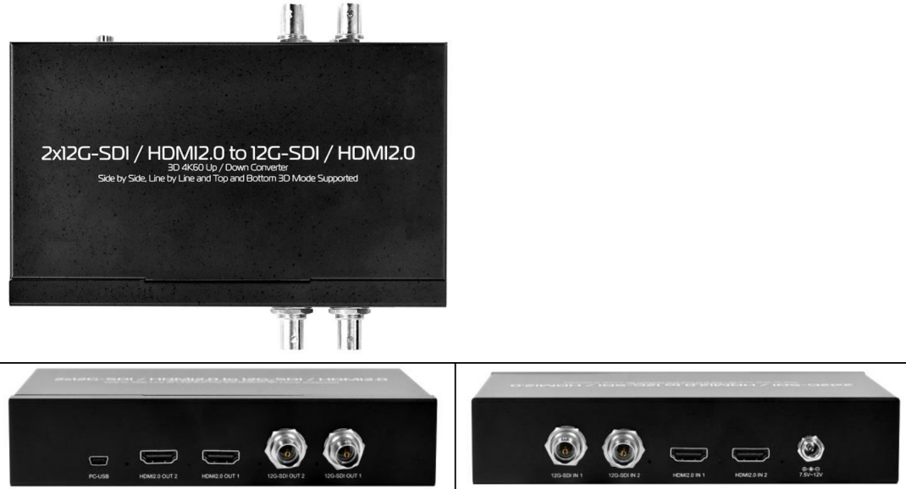
描述 | 2 × 12G-SDI/HDMI2.0 to 2 × 12G-SDI and 2 × HDMI2.0 Up/Down Converter with 3D Support
特征 | ● Side by Side, Top and Bottom, Line by Line 3D Mode and Frame  Sequential Support   Two 2D Video Convert to One 3D Video Support   One 3D Video Convert to Two 2D Video Support   I ↔ P Conversion ( Built-In Interlacer and DeInterlacer. )   60fps ↔ 59.94fps Conversion   Frame Rate and Format Up/Down Conversion
输入接口 | Video   HDMI2.0×2 ( 2D / 3D )   12G-SDI×2 ( 2D / 3D )
输出接口 | Converted Video   HDMI2.0×2 ( 2D / 3D )   12G-SDI×2 ( 2D / 3D )
输入格式 | SDI  12G-SDI  4096x2160p@60/50fps  3840x2160p@60/50fps  6G-SDI  4096x2160p@30/25/24fps  3840x2160p@30/25/24fps  3G-SDI  1920×1080p@60/50fps  HD-SDI  1920×1080p@30/25/24fps  1920×1080i@60/50fps (*)  1280×720p@60/50fps  HDMI 2.0  4096x2160p@60/50fps  4096x2160p@30/25/24fps  3840x2160p@60/50fps  3840x2160p@30/25/24fps  1920×1080p@60/50fps  1920×1080p@30/25/24fps  1920×1080i@60/50fps (*)  1280×720p@60/50fps  *: Interlaced input video is not supported for frame sequential output mode
输出格式 | SDI ( Up/Down Converted )  12G-SDI  4096x2160p@60/50fps  3840x2160p@60/50fps  6G-SDI  4096x2160p@30/25/24fps  3840x2160p@30/25/24fps  3G-SDI  1920×1080p@60/50fps  HD-SDI  1920×1080p@30/25/24fps  1280×720p@60/50fps  HDMI 2.0 ( Up/Down Converted )  4096x2160p@60/50fps  4096x2160p@30/25/24fps  3840x2160p@60/50fps  3840x2160p@30/25/24fps  1920×1080p@60/50fps  1920×1080p@30/25/24fps  1280×720p@60/50fps
音频输入 | SDI : Up to 8 Channels, 24bit, 48KHz  HDMI : Up to 8 Channels, 24bit, 192KHz
音频输出 | HDMI ( DVI-D ) /SDI : Up to 8 Channels, 24bit, 48KHz  3.5 mm Phone Jack : 2 Channels, 24bit, 48KHz
Plug & Play  即插即用 | ✓
电源 | 7.5V ~ 15V
Dimension  尺寸 | L:171mm×W:103mm×H:35.1mm
2/2

