TC-U8高清采集卡
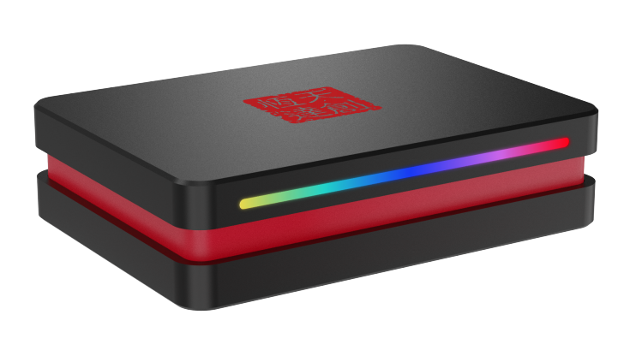
说明书

型号：TC-U8
感谢您购买 TC-U8高清采集盒。 请在使用前阅读本手册并将其保存在安全的地方以备将来参考。您可以使用该设备：采集和直播HDMI超清视频，最高达2160p60，并可以耳麦输入和线路音频输入混音，。

概览
包装内容
TC-U8高清游戏采集卡x1, USB-C转A数据线，说明书 x1

产品概览及连接
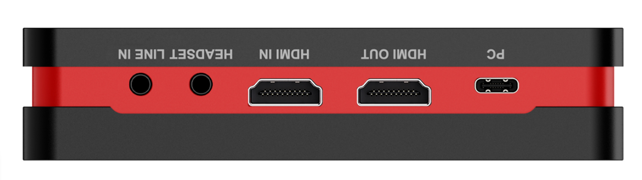

- PC：连接电脑USB接口
- HDMI OUT：HDMI输出接口, 连接到电视机
- HDMI IN：HDMI输入接口, 连接到游戏机或别的视频源。支持HDR及VRR输入。支持LPCM 5.1及7.1声道音频环出。
- HEADSET：耳麦接口，同时麦克风输入和耳机输出(支持CTIA标准)
- LINE IN：连接混音器，可将音频与视频进行混音
- 状态指示灯：设备通电 -红色渐变。连接HDMI信号源 -蓝色渐变。打开软件设备运行 -彩色缓慢闪烁。

软件
我们推荐免费的专业的直播及录制软件OBS, 下载地址：https://obsproject.com/

开始使用
设备选择
下载并安装后，双击桌面上的OBS Studio图标。 单击OBS面板左下角的图标+，然后选择视频采集设备。 在弹出的窗口中单击确定，在弹出的窗口中单击设备旁边的下拉框，然后选择TC-U8。
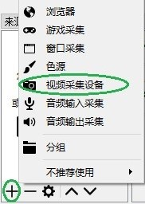

视频设置
设置完成后应该可以看到视频。 如果不能，并且在窗口上看到Check Resolutions Settings，则需要设置视频分辨率。 单击分辨率/ FPS类型，然后选择自定义，然后单击分辨率，选择一种与你的视频源分辨率相同或更小的分辨率。
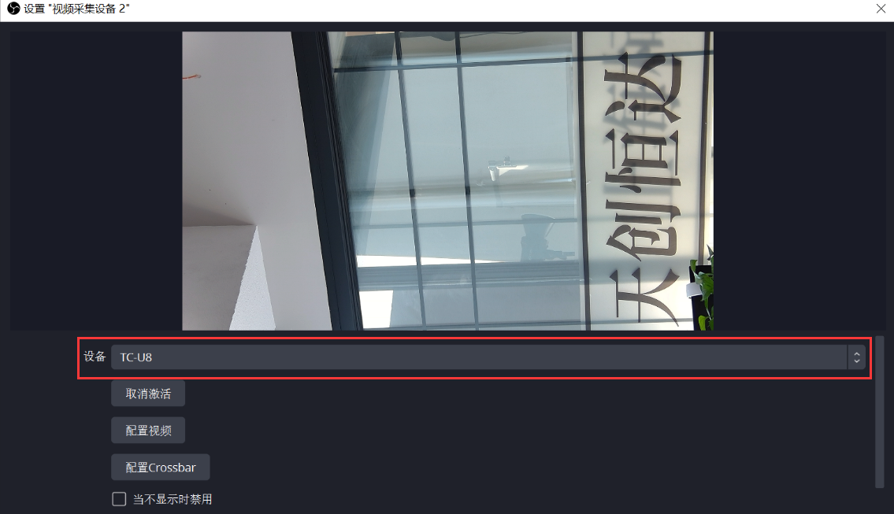

若您的视频源分辨率为3840 x 2160, 且将OBS分辨率也设置为3840x2160, 你还可能会发现画面超出了OBS画框的范围。此时可右击软件窗口，选择调整输出大小（到源大小）,则可将画面刚好填满画框。
您可以点击FPS以选择适当的帧率– 30,60,最高 或 匹配输出帧率。还可点击视频格式选择适当的视频格式 – NV12，I420，YUY2，RGB24，MJPG，或任意。
设备输出视频格式取决于分辨率,不同分辨率下不同视频格式的最高可达帧率（FPS）可能并不相同，具体对应关系请参考产品规格部分。

音频设置
请勾选使用自定义的音频设备，然后单击音频设备，选择HDMI（TC-U8），你应该能立即听到声音。单击确定完成设置。
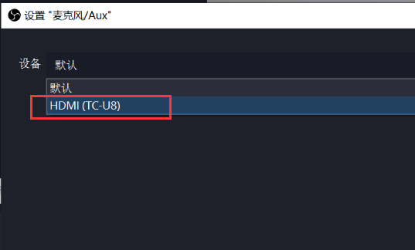

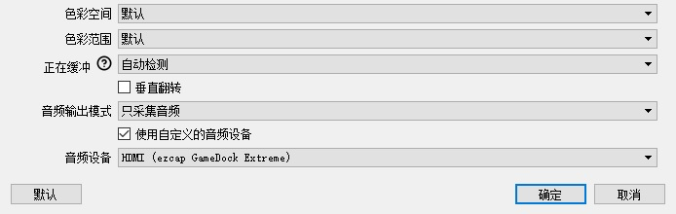

如果仍然听不到声音，请单击混音器界面的设置图标，然后选择高级音频属性。 在新的弹出窗口中，单击音频监听，然后选择仅监听（输出静音）。
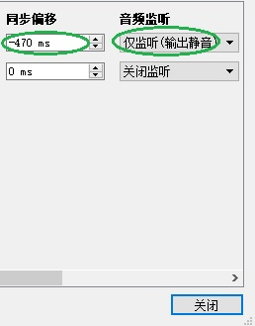
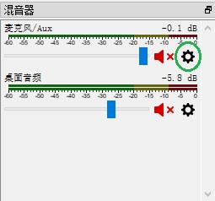

为了音视频同步,请在上述弹出的窗口中的同步偏移下方填写- 470ms.你可依据实际情况调整数值,直至音视频完全同步。最后单击关闭完成设置。
如果无法完成上述音频设置听到声音，还可以点击上面图片中音频输出模式, 选择输出桌面音频 (WaveOut)，这样就可以听到声音了。

录制
单击OBS面板右下角的设置按键，然后在弹出的设置窗口中单击左侧的视频。单击基础（画布）分辨率选择适当的分辨率,单击常用FPS值（帧率）选择FPS值。如果要录制120HZ视频，请单击常用FPS值（帧率）本身的下拉框，选择整数FPS值（帧率），然后在右侧栏框处输入120。
在设置完成后，单击设置界面右下角的应用和确定按键以保存设置。
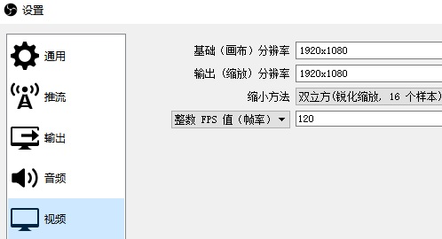

在各项设置完成后，单击设置面板右下角的应用和确定，然后只需单击开始录制即可开始录制视频，单击停止录制即可停止录制。

推流（直播）
单击软件界面的设置按键，然后点击设置面板左侧的输出，在串流栏目下，可以设置串流的视频比特率，编码器，音频比特率（根据计算机配置及网络速度进行调整）。单击设置面板左侧的推流图标，然后单击服务这一栏旁边的下拉框以选择所需的软件平台，点击设置面板右下角的应用和确定图标完成设置。单击OBS软件面板右下角的开始推流开始直播，点击停止推流停止本次推流。
注：您可以单击软件界面顶部的帮助菜单了解更多OBS的操作和方法.

产品规格
接口：USB 3.2 (Gen 1) Type-C (即插即用，UVC)
视频输入/输出（环出）：HDMI® 2.0 enabled
音频输入：HDMI2.0，3.5mm线路输入（3极TRS），3.5mm耳麦输入（4极CTIA）
音频输出（环出）：HDMI2.0，3.5mm耳麦输出（4极CTIA）
最高HDR环出分辨率：2160p60，1440p144/120，1080p240
最高VRR环出分辨率：3840x 2160 - VRR(48-60 Hz)，1920 x 1080 - VRR(48-120 Hz)。（注：不支持YCbCr420格式VRR输入。比如XBOX X1，请勾选允许YCC 4:2:2以获取VRR功能。）
最高录制分辨率：
3840 x 2160 - 60fps/MJPG，30fps/NV12/I420
2560 x 1440 - 144fps/MJPG，60fps/NV12/I420，50fps/YUY2
2560 x 1080 - 60fps/NV12/I420/YUY2/MJPG
1920 x 1080 -240fps/MJPG ,120fps/NV12/I420，60fps//YUY2/RGB24/P010
1280 x 720 - 60fps/NV12/I420/YUY2/RGB24/MJPG
尺寸 (长 x 宽 x 高)：151 x 121 x 22 mm
* HDMI、HDMI High-Definition Multimedia Interface等词汇、HDMI 商业外观及HDMI 标识均为 HDMI Licensing Administrator, Inc. 的商标或注册商标。

电脑系统需求
Windows 10 x64 / 11 x64，USB 3.2 (Gen 1)UVC接口 x1
台式机：Intel Core i5-6XXX或更佳，NVIDIA GeForce GTX 1060或更佳。
笔记本：Intel Core i7-7700HQ或更佳，NVIDIA GeForce GTX1050 Ti或更佳。
推荐8 GB内存。

macOS 11 / 12，USB 3.2 (Gen 1)UVC接口 x1
Apple M1或Intel i7 quad-core或更佳, Radeon Pro 555（2 GB VRAM），16 GB 2400 MHz DDR4内存。
天创恒达TC-U8说明书

DockExtreme
manual

Model: TC-U8

Thanks for purchasing TC-U8 Dock Extreme capture card. Please read this manual before use and keep it in a safe place for future reference. You can use this device: Capture and stream HDMI video up to 2160p60 or 1080p120 resolution on your computer, and mix microphone and audio line input for mixing audio.

Overview
In the Box
TC-U8 Dock Extremex1, USB-C to A cable x1, Manual x1

Product Overview and Connections

- PC: To connect to computer USB port.
- HDMI OUT: HDMI output port, connect to TV or monitor.
- HDMI IN: HDMI input port, connect to game console or other video source. Supports HDR and VRR input. Supports LPCM 5.1 and 7.1 channel audio pass through.
- Headset: 3.5mm audio for output to earphone and microphone input (CTIA).
- LINEIN: Connect to Audio mixer, and mix the audio with video together.
- Status Indicator: Power on – Red, HDMI input – Blue, Device running –Colorful slow flashing.

Software
For professional live streaming or recording, we suggest use OBS, download link:https://obsproject.com/

Start Work
Select Device
After download and installation, double click OBS Studio.Click icon +under Sources window, and select Video Capture Device. Click OKin thenew pop-up window. Please click Device and select TC-U8 Dock Extreme.
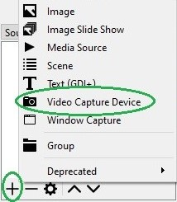

Video Setting
You should get the video in window. If not, and you see Check Resolutions Settings on the window, you need to set the video resolution. Click Resolution/FPS Type and select Custom, then click Resolution to select one resolution that same or smaller as the resolution of your video source.

If resolutionsof video source device output are3840 x 2160, you may find that the viewing picture is way out of the frame of OBS. Right click image window of OBS, select Resize output(source size), and you will get the whole picture.
You can click FPSto select the appropriate FPS - 30,60,Highest FPS, or Match Output FPS, and click Video Format to selectRGB24, NV12,YUY2, I420, P010, or MJPG.
The video format options depend on resolution, the max FPS depends on both resolution and video format. Please refer to the Specifications part for the corresponding relationship.

Audio Setting
Please tick Use custom audio device, and click Audio Device and select HDMI (TC-U8), you will hear the sound now.
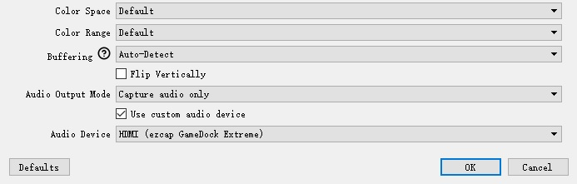

If you still cannot hear the sound, please click Settingunder Audio Mixer and Video Capture Deviceat the bottom middle of OBS panel as below picture and select Advanced Audio Properties. Then click Audio Mornitoring and select Monitor Only (mute output).
You still cannot get the sound after above setting, please clickAudio Output Mode to select Output desktop audio (WaveOut).You should get the sound.
Please set to - 470ms under Sync offset, for audio and video sync, you can adjust it till your audio video is synchronous.
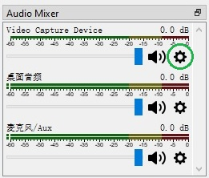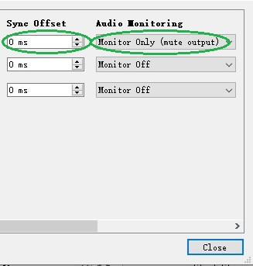

Recording
Click Settings of OBS panel, and clickVideo. Click Base (canvas) Resolution to select the appropriate resolution, and click Output (Scaled) Resolution to select the output resolution. Click Common FPS Values to select the FPS values. If you want to record 120HZ video, please click Common FPS Values and selectInteger FPS Values, then enter120 in the window on the right.
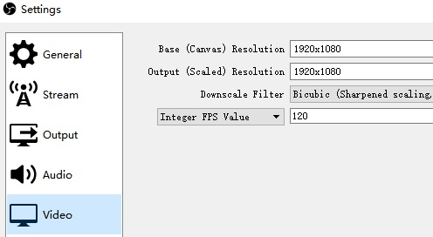
After setting, click Apply and Ok, then simply click Start Recording to start recording video, and click Stop Recording to stop recording.

Streaming
Click Output in the Settings panel, in the Streaming column, set video quality for streaming (adjust depends your computer, network speed), then click icon Apply and OK. Click Stream, then you can click Service to choose the software platform you want, then click icon Apply and OK.
Click Start Streaming to start streaming, and click Stop Streaming to stop streaming.
Note: Please click the help at the top of the OBS, and learn more aboutOBS.

Specifications
Interface: USB 3.2 (Gen 1) Type-C (plug and play, UVC)
Video Input / Output (Pass-Through): HDMI ® 2.0 enabled
Audio Input: HDMI 2.0, 3.5mm Line In (TRS 3-pole), 3.5mm headset microphone input (CTIA 4-pole)
Audio Output (Pass-Through): HDMI 2.0, 3.5mm headset earphone output (CTIA 4-pole)
Max. HDR Pass-Through Resolution: 2160p60 HDR, 1440p144/120, 1080p240
Max. VRR Pass-Through Resolution:3840x 2160 - VRR(48-60 Hz), 1920 x 1080 - VRR(48-120 Hz). (Note: YCbCr420 VRR is not supported. Such as XBOX X1, please tick Allow YCC 4:2:2 settings to allow VRR)
Max Record Resolution:
3840 x 2160 - 60fps/MJPG, 30fps/NV12/I420.
2560 x 1440 - 144fps/MJPG，60fps/NV12/I420，50fps/YUY2
2560 x 1080 - 60fps/NV12/I420/YUY2/MJPG.
1920 x 1080 -240fps/MJPG ,120fps/NV12/I420，60fps//YUY2/RGB24/P010
1280 x 720 - 60fps/NV12/I420/YUY2/RGB24/MJPG.
Dimensions (W x D x H): 151 x 121 x 22 mm

* The terms HDMI, HDMI High-Definition Multimedia Interface, HDMI trade dress and the HDMI Logos are trademarks or registered trademarks of HDMI Licensing Administrator, Inc.

Operating System
Windows 10 x64 / 11 x64，USB 3.2 (Gen 1)UVC Portx1
Desktop: Intel Core i5-6XXX or above, NVIDIA GeForce GTX 1060 or above.
Laptop: Intel Core i7-7700HQ or above, NVIDIA GeForce GTX1050 Ti or above.
8 GB RAM recommended.

macOS 11 / 12, USB 3.2 (Gen 1)UVC Port x1
Apple M1 or Intel i7 quad-core or above, Radeon Pro 555 with 2 GB of VRAM, 16 GB of 2400 MHz DDR4 memory.

